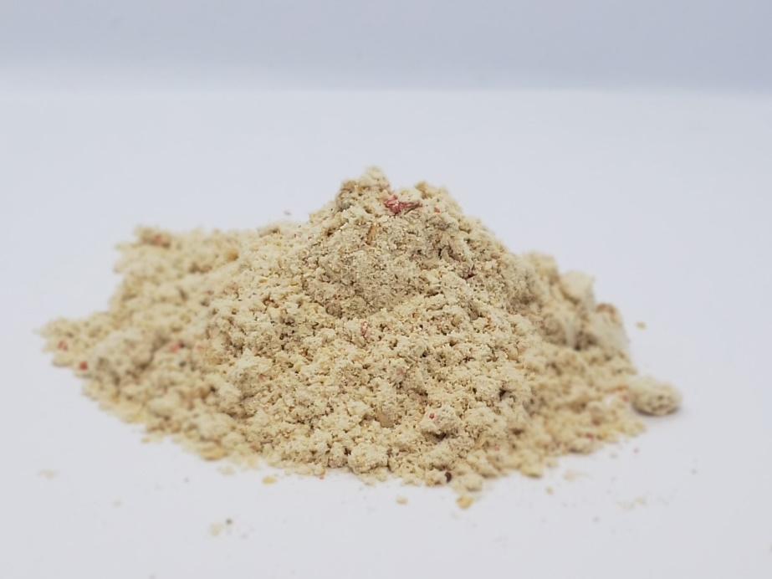

Protein Blend SS

Description:

|  |  |
| --- | --- |
|  | Typical Value |
| Crude Protein, % | 67.0 |
| Crude Fat, % | 2.3 |
| M.E. (calculated) | 3,711 kcal/kg |

Analysis:

Features:

* + - Contains purified soy proteins-soy isolate and soy concentrate.
    - Higher protein content compared to other specialty protein ingredients.
    - Well-balanced essential amino acid profile.
    - Highly-digestible amino acids (high standard ileal digestible amino acid levels).
    - Low in anti-nutritional components.
    - Economical replacement for other specialty proteins (lower cost per unit of protein).
    - Free-flowing.
    - Available in bulk and totes.

**Protein Blend SS** is a formulated blend containing high-quality soy protein ingredients. The soy protein isolate and concentrate in Protein Blend SS yields a well-balanced essential amino acid profile with excellent digestibility. Typical inclusion levels are 4 – 12% in nursery pig diets.